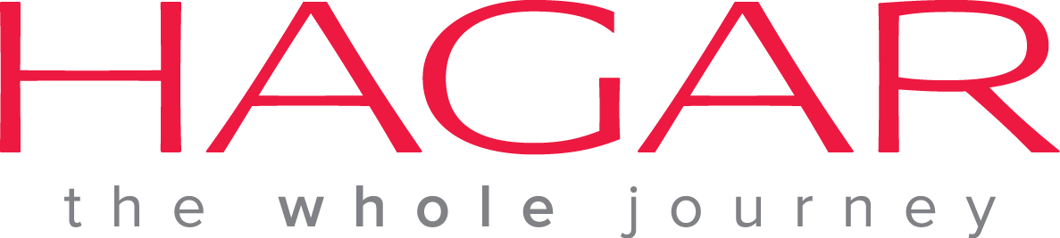
Vacancy Announcement

Hagar International Vietnam, an international NGO based in Hanoi, invites applications from interested and experienced Vietnamese candidates for the following position.

Position: Therapeutic Arts Officer
Start date: ASAP

Job Responsibilities:
- Create arts-based techniques which clients can apply along with assessment, therapeutic objectives, and evaluations
- Research and create new methodologies in arts-based therapies, improvise content, and set best practices
- Keep policies and procedures up to date and evidence based
- Provide support in training and treatment of clients in individual and group settings
- Organize group activities and events
- Organize volunteers, visitors and staff members leading classes
- Provide visitors with interesting experiences while upholding the client protection policies
- Inform case managers of any concerns with the behaviour or change in demeanour of a client
- Keep accurate files of clients’ participation and their response to therapeutic classes and sessions
- Provide therapeutic support to clients through mentoring and emotional support and being observant of changes in client demeanour
- Participate in fundraising for Hagar Vietnam
- Any other activities as assigned
Qualifications:
- Bachelor Degree in Art Therapy, Arts, Education, Psychology, Management, or related field. (Prefer Master’s Degree in related field)
- Computer skills including MS Word, Excel, Powerpoint; internet and email
- Able to communicate in written and verbal English
- Proven ability to work independently and as part of a team
- At least three years’ experience teaching
- Proven ability to organize projects and personnel
Preferred:
- Minimum of three years’ experience with victims of gender based violence
- Prior experience utilizing therapeutic arts with victims of abuse and/or trauma

Please send cover letter and CV in English to info.vn@hagarinternational.org
Deadline for submissions: 30 August 2015

