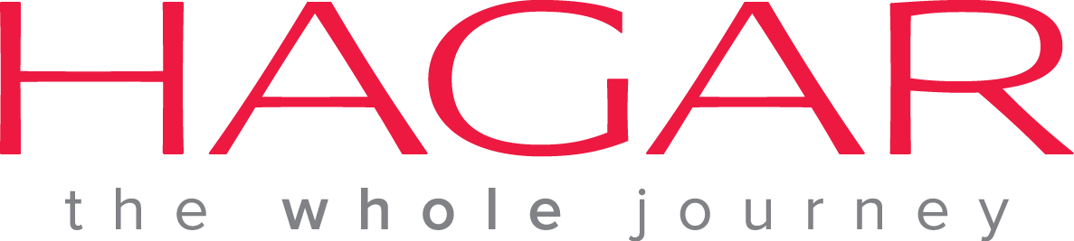 Vacancy Announcement

Hagar International Vietnam, an international NGO based in Hanoi, invites applications from interested and experienced Vietnamese candidates for the following position.

Position: Public Outreach Officer
Start date: ASAP

The Outreach Officer has an important role at Hagar building and maintaining relationships with partners and stakeholders, and identifying new clients for Hagar’s program.

Job Responsibilities:
- Any other activities as assigned
Qualifications:
- Bachelor Degree in Social Sciences (Prefer Master’s Degree in Social Sciences)
- 3 - 5 years experience with an NGO, with experience working with government and local partners
- Proven ability to work independently
- Ability to work with diverse personalities, persons of all ages, ethnicity and sexual orientation
- Computer skills including MS Word, Excel, Powerpoint; internet and email
- Ability to establish a trusting relationship with traumatized clients, especially women and children
- Excellent management and record keeping skills
- Basic social work skills: listening, empathy, reflection
- Ability to respect the need for confidentiality, especially for the high risk situation of trafficked persons or domestic violence victims
- Ability to adapt to the changing needs of clients
- Detail oriented
- Ability to keep professional boundaries, code of ethics and address all personal issues, which may affect your work
- A professional demeanor at all times including in high stress situations
- Willing to work as part of a team

Please send cover letter and CV in English to info.vn@hagarinternational.org
Deadline for submissions: 30 August 2015

