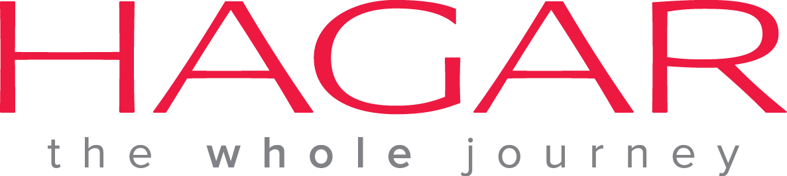 Vacancy Announcement

Hagar International Vietnam, an international NGO based in Hanoi, invites applications from interested and experienced Vietnamese candidates for the following position.

Position: Project Officer
Start date: ASAP

The primary goal of this position is to support the effective implementation of projects at Hagar International in Vietnam through the management of project activities and partnerships with partners and stakeholders

Job Responsibilities:
- Support the design of the project implementation plan (including time frame, financial planning, and activity plan) and the development of agreements between project partners
- Develop and maintain relationships with local partners
- Manage project activities according to the project document, the donor agreement, and the project work plan
- Monitor the expenditure of the project, and counterpart expenditure, ensuring accountability to the donor by following donor restrictions and requirements
- Organise the training of partners, project site staff and beneficiaries
- Liaise with government offices in order to establish and maintain relationships for Hagar and participating in trafficking working groups and network meetings
- Research and keep informed on mobility and trafficking developments in Vietnam
- Support development of new projects and fund-raising activities
- Support and representing Hagar as necessary and translating documents and meetings when needed

Qualifications:
- Bachelor Degree in social sciences, management, social work, communications, or related field. (Prefer Master’s Degree in related field)
- At least 5 years experience with NGOs or development organisations with a role in management and supervision
- Experience in multi-cultural environments with strong interpersonal skills and involvement in teams
- Proven ability to work independently
- Excellent written and spoken English
- Computer Skills: Expert level in Microsoft office especially Excel and Word
- Ability to prioritize and work to deadlines
- Good communication, inter-personal and facilitation skills with positive attitude
- Excellent documentation skills
- Ability to work independently and as part of a team

Please send cover letter and CV in English to info.vn@hagarinternational.org
Deadline for submissions: 30 August 2015

