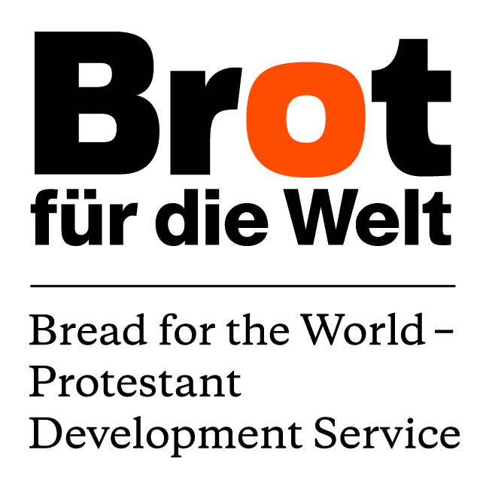
TERMS OF REFERENCE (ToR)
for the development of a Research Paper
“Ecologically Sustainable and Social Inclusive Agricultural Sector
in Vietnam”

Background and Assignment
In a rapidly changing world, development and especially poverty reduction continue to be major policy concerns on the international as well as on national agendas. These concerns are elevated to a new level with the threat of climate change and its consequences especially for vulnerable groups, which endangers progress already made in these fields. Climate change also complicates the process of achieving development and poverty reduction as such: it causes more severe poverty (for example, by loss of fertile land or reduced yields) and poverty pushes people to exploit natural resources (such as wood) in an unsustainable manner leading to stronger adverse effects of climate change.
Therefore, targeting both, the thread of climate change, which is continuously triggered by the release of green house gas (GHG) and poverty reduction is crucial, ideally with an integrated approach. In order to contribute to reduced green house gas emissions and promote green growth the international organizations Friedrich-Ebert-Stiftung (FES), Bread for the World (BftW) and World Wide Fund for Nature (WWF) have jointly initiated a Low Carbon Development (LCD) Project for the years 2013 and 2014 which is implemented in four different countries.
Vietnam has been selected to host one of the Low Carbon Development projects for a number of reasons. Numerous environmental problems occur as a result of the country’s poverty alleviation efforts such as a rapid loss of natural habitats and of biodiversity, increasing pollution of air as well as water and soil. Of particular concern regarding climate change is the sharp increase in energy consumption, caused by the expansion of energy-intensive sectors such as manufacturing, transport and consumer habits.
But also the energy consumption and notably the significant contribution of GHG emissions of the agricultural sector cause concern and demand for solutions beyond today’s trends and practises. Agriculture is directly responsible for 14 percent of the global green house gas emissions and additionally drives deforestation and land degradation, which account for another 17 percent of the emissions. At the same time, the impact of climate change will reduce productivity and lead to greater instability of the sector in terms of crop and livestock production, fisheries and forestry. Especially poor communities already experience high levels of food insecurity, face environmental degradation which result in reduced yields and have as well limited options for coping with changed weather patterns. Thus, an adaptation and transformation of the agricultural sector is urgently needed to respond to climate change and to achieve a sustainable increase of agricultural productivity with less GHG emissions.
In order to move towards more sustainable development, including climate change mitigation, Vietnam has promulgated a National Green Growth Strategy (GGS), which addresses in a comprehensive manner the issues of green growth and low carbon development. In that sense, the GGS can be considered as the LCDS for Vietnam. The GGS was promulgated in September 2012 and its action plan was approved by the Government of Vietnam by the end of March, 2014.
Within this collaboration, the need for a research paper with policy recommendations, describing main characteristics of a sustainable and social inclusive agricultural sector in Vietnam was identified.

Objective of the study
A report is available, including a short policy paper with recommendations for decision makers, providing an overview of existing and recommended Vietnamese practises relating to low carbon development in a socially inclusive agricultural sector.

The planned research paper is expected to include the following contents:
- Overview of the existing strategies to support and promote the agricultural sector in Vietnam including livestock, fisheries and the forestry sector
- Brief overview of the present agricultural systems practised in Vietnam including an assessment of its impacts on the emission of green house gases.
- Critical analysis of the recently approved Green Growth Strategy Action Plan (GGS AP) as well as the Climate Change Strategy itself with a special focus on the agriculture related components.
- Development of recommendations for major characteristics and suggestions for implementation, including advanced practices recommended by MARD for Green Growth for an ecologically sustainable and social inclusive agricultural sector.

Key research questions:
- Which agricultural production systems and production methods in Vietnam are significant emitters of GHG ?
- How does the Green Growth Strategy Action Plan respond to a reduction of these emissions and what are suggested alternatives to achieve a more climate-resilient as well as climate-friendly agriculture?
- What are the expected changes Vietnam will introduce in the agricultural sector to reduced GHG and how are these changes assessed by the consultant?
- What are the potential positive or negative effects of these changes on food-security and the livelihoods of the poor population in rural areas and what are expected measures to address possible trade-offs?

Methodology
- Review of available documents at BftW/other members of the consortium/from internet search/contacts to research institutes, ministries, departments, donors, individuals etc.
- Interviews with representatives of relevant institutions (Government ministries and departments, multilateral organisations, Donors, INGO’s, VNGO’s, farmers)
- Visit of up to 2 provinces who are collaborating with “the consortium” in the GGS AP implementation and meeting with representatives of Provincial Dep. of Agriculture and Rural Development (DARD).
Structure and length of the report
The expected report should be structured as follows:
The total length of the report should not go beyond 50 pages excluding annexes, photos and bibliography. This includes an up to 2 pages summary and up to 5 pages of policy recommendations.
The annexes should as well include background information about the two visited provinces.
Schedule
The research/study should be carried out between June and October 2014.
Activities | Time in days
Desk study | 8
Interviews | 3
Trip to up to two selected provinces | 5
Preparation of report | 10
Debriefing “the consortium”, finalize report | 4
Total consultancy days | 30

The draft report should be submitted to BftW-PDS until 30.9.2014. BftW and “the consortium” will review the report and ask for clarifications and/or suggest corrections. The consultant will submit the final report in English by 15 October 2014.
Cost estimation:
The budget should be agreed between BftW-PDS Regional Office Vietnam-Laos and the consultant, based on the consultants offer and the BftW cost norms.
Payment of the total cost, including consultancy fees and travel, accommodation, DSA, will be done by bank transfer according to the following schedule:
- Instalment of 30 % upon commencement of the assignment.
- Instalment of 40 % upon submission of draft report.
- Instalment of 30% latest 10 days after the acceptance of the final report.
Qualification of the consultant:
- Relevant and sufficient academic background, minimum MSc. Degree.
- Extensive and proven experience on policy analysis of agriculture and/or agriculture related sectors as well as relevant national support programmes for the sector.
- Experiences/knowledge about GHG emission and/or LCD policies.
- Knowledge and experience on principles of climate smart agriculture and sustainable agricultural methods.
- Relevant and sufficient experience in preparing research papers and communication in English language.
- Communication skills, proven ability to meet deadlines.

Please send your proposal, including your suggested consultancy rate, to BftW until
Monday, 26 May 2014 4 p.m.
Bread for the World Regional Office Vietnam – Laos
Mrs. Nguyen Ngoc Dung (dung.nguyenngoc@brot-fuer-die-welt.de)
Hanoi, 06.05.2014

The Government of Vietnam does not aim at designing a LCDS as its GGS and NCCS already cover all the issues relating to low carbon development.

