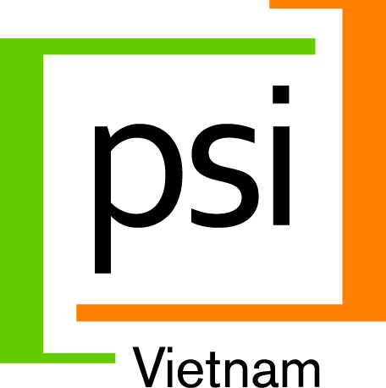
Population Services International (PSI) is a leading global health organization with social marketing and social franchising interventions in Vietnam to address WASH, Tuberculosis, HIV/AIDS, Hepatitis C, and Hypertension. PSI uses private sector approaches to improve the health of Vietnam’s low-income and vulnerable communities in close to 20 provinces thorough Vietnam. Working in partnership with the Government, private sector and civil society partners, PSI harnesses the power of markets to empower underserved populations to lead healthier lives. For more information: www.psi.org

PSI currently seeks an experienced Sanitation Professional to work with our team to identify gaps in the rural sanitation supply chain in select rural markets, as well as feasible, market and consumer-driven solutions to fill gaps identified.
Job Title: Sanitation Consultant
Reports to: Country Director

Duration of Appointment: Approximately 2-4 weeks in May-June 2014

Job purpose: The Sanitation Consultant will conduct and document a market scan of rural sanitation supply chain in at least 2 rural provinces of Vietnam, in consultation with PSI’s Hanoi and field-based team members familiar with WASH programming issues, rural markets and social marketing techniques. The objective of this consultancy is to identify commercially viable sanitation business models, which will make investment in hygiene sanitation attractive both to rural households and to private sector partners/entrepreneurs along the value chain.

Major duties:

- Work with PSI’s Director of Product Social Marketing and PSI’s global WASH Advisor to design, conduct, and document a market scan of rural sanitation supply chain in at least 2 provinces
- Draft a summary ppt and written report outlining barriers and opportunities in the existing sanitation supply chain, including specific description of commercially viable sanitation business models which will address four critical elements: i) access to increase the number of conveniently accessible, affordable sanitation providers and services; ii) equity: ensure that bottom of the pyramid rural consumers’ needs and preferences are met; iii) quality of sanitation products and services should meet national standards as well as consumer preferences; iv) consumer demand: increase rural household intent and motivation to invest in improved sanitation. Business model options should include specific suggestions for all 4 Ps: product/service specifications, pricing, promotion and distribution.
- Link proposed business model options with analysis of which—if any—of current sanitation product/service models and innovations being utilized or piloted in Vietnam are likely to be viable components of the business model based on market scan findings and technical understanding of hygienic sanitation standards.
- Outline terms for prospective partnerships between PSI and sanitation product/service providers to improve convenient access to quality, affordable commercial sanitation products and services, including training, branding, and other opportunities for PSI to improve sanitation product/service provider business viability.
Selection criteria
- University degree or higher in business administration, engineering or another relevant field
- At least 5 years of experience in sanitation programming in Vietnam
- Prior experience in sanitation supply chain strengthening, commercial or social marketing interventions an advantage;
- Private sector experience preferred.
- Excellent verbal and written English, as well as Vietnamese communication skills

A competitive remuneration package will be offered to the successful candidate

Interested candidates are requested to submit detailed curriculum vitae (CV) with a letter of interest indicating as well as copies of relevant certificates/degrees to HR Department, PSI Vietnam by 21 April 2014; or postage to our address at 11th Floor, VINAFOR building, 127 Lo Duc, Hai Ba Trung, Hanoi; Email:hr@psi.org.vn. Only short-listed candidates will be contacted for interviews. Please do not contact via telephone. Dossier will not be returned

