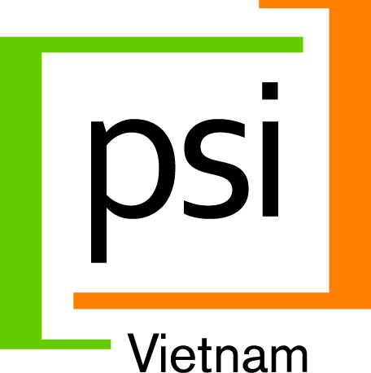
Population Services International (PSI) is a leading global health organization with social marketing and social franchising interventions in Vietnam to address HIV/AIDS, Hepatitis C, Safe Water/Hygiene, Tuberculosis and Hypertension. PSI uses private sector approaches to improve the health of Vietnam’s low-income and vulnerable communities in close to 20 provinces. Working in partnership with the Government, private sector and civil society partners, PSI harnesses the power of markets to empower underserved populations to lead healthier lives. For more information: www.psi.org

PSI currently seeks a highly creative professional who is interested in applying commercial marketing expertise to achieve social good to join our dynamic, results-focused team in Hanoi. Are you passionate about marketing? Do you feel you have more to give? Get us to notice you and join our inspiring mission.
Job Title: SENIOR MARKETING COORDINATOR (re-post)
Reports to: Country Director

Job purposes: The Senior Marketing Coordinator will play a key role in developing consumer-focused messaging and materials designed to motivate healthier behaviors, including correct and consistent use of essential health products and services. S/he will leverage experience in commercial marketing to develop engaging, out of the box, purposeful and locally appropriate social campaigns. S/he will identify and apply cost-efficient channels to implement multi-channel campaigns using social media, online, outdoor billboards, print, community engagement and other channels as appropriate. S/he will lead the design of 360-degree campaigns that will change people’s lives. This position will help expand PSI’s partnerships with marketing agencies and other partners involved in social mobilization and behavior change communication. S/he will work closely with advertising agencies as well as governmental agencies and partner organizations. S/he will work with the most creative and committed people working in public health in South East Asia.

Major duties:
- Develop engaging, game changing, and leading edge marketing and communication strategies and annual marketing plans to motivate healthier behaviors.
- Closely monitor marketing implementation and expenditure against strategies/budgets to ensure effective execution & to actively collect feedback from target audiences about how to improve future campaigns.
- Help design & facilitate participatory trainings, outreach tools and community events to engage audiences with effective face-to-face communication
- Work closely with Research Manager, from the ‘marketing perspective’ to ensure that research studies generate practical information that is used to inform effective behavior change communication and marketing campaigns.
Selection criteria
- University degree or above in communications or marketing.
- At least 4 years work experience for a commercial marketing agency or an advertising agency with non-profit as well as commercial clients
- Previous experience developing social or health communications campaigns a plus.
- Proven ability in taking initiative and creatively solving problems.
- Excellent analytical and critical thinking, and verbal as well as written communication skills
- Enthusiasm, out of the box thinking, a desire to make a positive impact and a team player
- Someone who understands that great marketing can make a difference. Are you that person? Apply today.

A competitive remuneration package will be offered to the successful candidate
Interested candidates are requested to submit detailed curriculum vitae (CV) with a letter of interest indicating the position you are applying for as well as copies of relevant certificates/degrees no later than 17:00, April 4th, 2014 to HR Department, PSI Vietnam; Address: 11th Floor, VINAFOR Building, 127 Lo Duc Street, Hai Ba Trung, Hanoi; Email: hr@psi.org.vn; Only short-listed candidates will be contacted for interviews. Please do not contact via telephone. Dossier will not be returned

