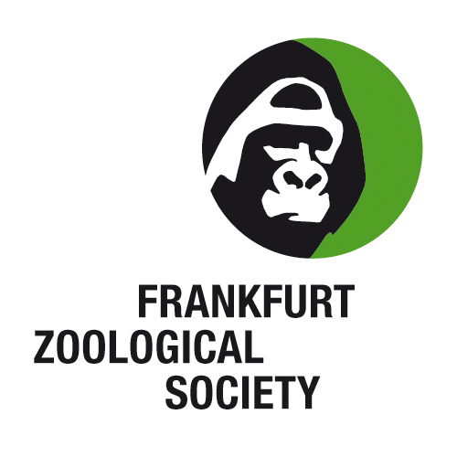 | 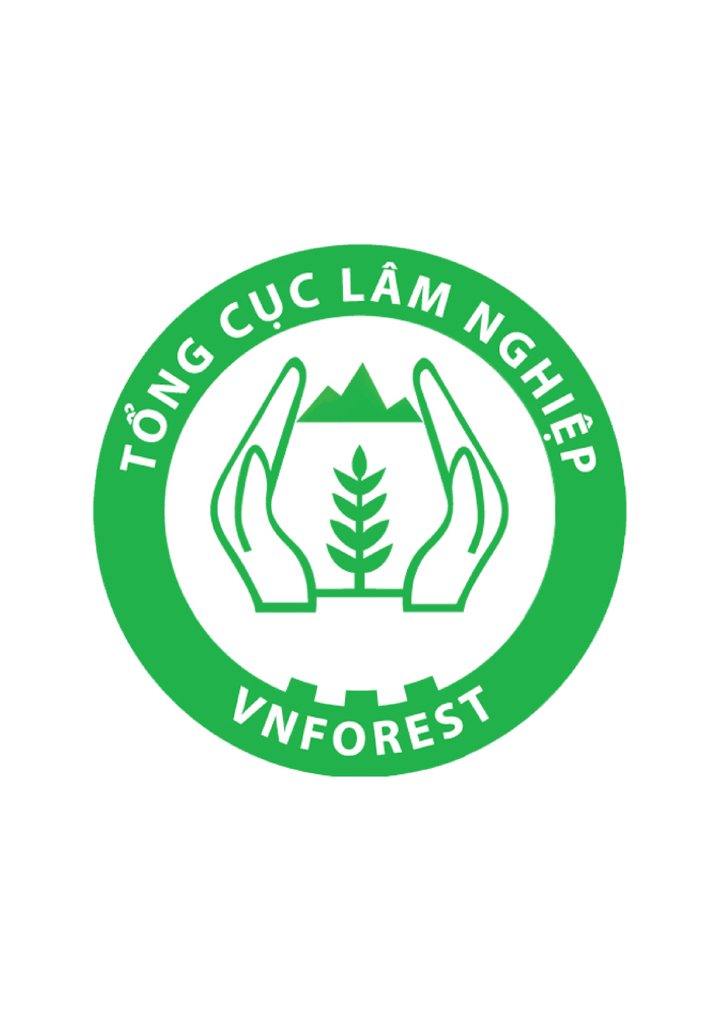 | 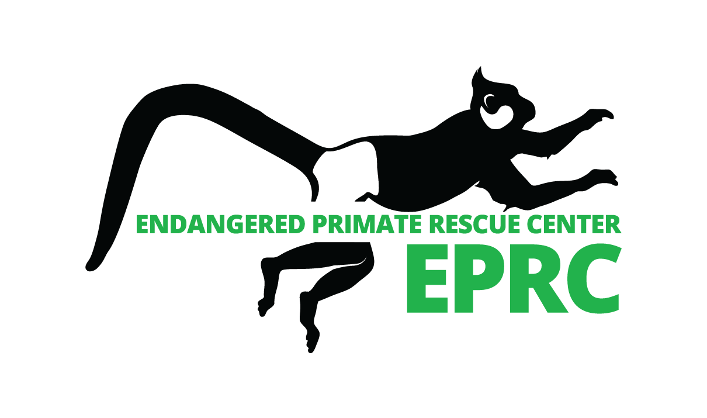 |  | 

Announcement

The Endangered Primate Rescue Center and Cuc Phuong National Park are pleased to announce the

3rd International Conference
Conservation of Primates in Indochina
8. – 12. October 2013
in Cuc Phuong National Park, Vietnam

The conference will be arranged under the patronage of the Administration of Forestry of Vietnam with additional support from Frankfurt Zoological Society and Leipzig Zoo, Germany.
In 2003 the first international primate conference in Vietnam ‘Conservation of Primates in Vietnam’ took place in Cuc Phuong National Park, organized by Frankfurt Zoological Society. This first conference hosted 110 participants from 13 countries.
In 2008 the second international primate conference ‘Conservation of Primates in Indochina’ included 130 participants from 10 countries.
Keeping to this schedule of quinquennial primatological conferences in Cuc Phuong we would like to invite all interested primatologists and conservationists to attend the third conference ‘Conservation of Primates in Indochina’. This will allow the exchange of information about primate conservation work in the region including the results of research and status of primates, and will be a step in the preparations for the IPS Congress in August 2014.
Aside from scientific presentations pre and post conference tours are plannned. Integrated in the program is a field trip to Van Long Nature Reserve with the possibility to observe the endemic and ‘Critically Endangered’ Delacour’s langurs (Trachypithecus delacouri) in their natural habitat.
We hope to provide an attractive agenda with interesting presentations, field trips, and a pleasant stay at Cuc Phuong National Park with the possibility to visit the Endangered Primate Rescue Center which currently houses more than 150 primates representing 15 species of Vietnams’ endangered primates.

3rd INTERNATIONAL CONFERENCE
PRIMATE CONSERVATION IN INDOCHINA

CONFERENCE PROGRAM

Tuesday,  8. October | 12am  3am  6:30pm | Transfer by Bus from Hanoi to Cuc Phuong National Park  (130 km; 3 hours drive)  Bus starts from Hanoi Opera (City Center)  Arrival in Cuc Phuong National Park  Check in at the National Park Guest House  Possibility to visit the Endangered Primate Rescue Center,  Turtle Conservation Center, National Park’s Visitor Center  Welcome dinner
Wednesday,  9. October | 8am  9 -12am  12:30 - 1:30pm  2pm - 5pm  6pm  7:30pm | Breakfast  Opening and Presentations (1)  Lunch  Presentations (2)  Dinner  Possibility to visit the Small Carnivore and Pangolin Project
Thursday,  10. October | 8am  9-12am  12:30 - 1:30pm  2pm - 5pm  6pm  7:30pm | Breakfast  Presentations (3)  Lunch  Presentations (4)  Dinner  Possibility to visit the Small Carnivore and Pangolin Project

Friday,  11. October | 8am  9 -12am  12:30 - 1:30pm  2pm - 3pm  3pm - 5:30pm  6pm-9pm  9pm | Breakfast  Presentations (5) and closing remark  Lunch  Possibility to visit the Endangered Primate Rescue Center,  Turtle Conservation Center, National Park’s Visitor Center Van Long Nature Reserve  Closing and dinner at Van Long Nature Reserve  Return to Cuc Phuong National Park
Saturday,  12. October | 8am  9am  12am | Breakfast  Departure to Hanoi  Arrival Hanoi

After the conference we will offer parallel field trips to Cat Ba Island in Ha Long Bay with the possibility to observe Cat Ba langurs (Trachypithecus poliocephalus), to Kon Cha Rang Nature Reserve in the Central Highlands of Vietnam to observe grey-shanked douc langurs (Pygathrix cinerea), to Son Tra Nature Reserve, Danang to observe red-shanked douc langurs (Pygathrix nemaeus), to Khau Ca Nature Reserve to observe Tonkin snub-nosed monkeys (Rhinopithecus avunculus), and to Trung Khan Nature Reserve with the possibility to see eastern black gibbons (Nomascus nasutus).

REGISTRATION AND FEE
Participants are kindly asked to fill out the registration form and return it to the organizers at the email address eprc.info@gmail.com by July 31st.

The registration fee is US$200 will be paid at the registration desk.
Reducing the fee for a shortened participation is not possible.
This includes:
- Transportation by Bus from Hanoi to Cuc Phuong National Park and return
- Attendance at the Conference
- Conference material
- 3 breakfasts, 2 lunches, 3 dinners (including welcome and farewell dinner)
- Coffee breaks
- fee and boat ticket for the visit to the Van Long Nature Reserve
g. Accommodation for 3 nights at Cuc Phuong National Park

PRESENTATIONS AND ABSTRACTS
The organizers of the conference invite all participants to present their work. The contents of the presentation should focus on relevant information on primate species of Indochina. Presentations are planned for 15 minutes + 5 minutes for questions and discussions.
Abstracts should be submitted by May 30th to eprc.info@gmail.com.

Format and layout instructions for abstracts:
- Abstract should be in English
- Font 12 points, Arial, single spaced
- Title in bold and capital letters above
- Authors name, affiliation, mail address
- 300 word’s (including title, authors, affiliation)
- Do not include figures, tables and special mathematical symbols

TRAVEL INFORMATION
Participants should arrange their own travel to Hanoi.
The busses from Hanoi to Cuc Phuong National Park will start in the morning on October 8th, 9am at the Opera Hanoi.
After the conference the busses from Cuc Phuong arrive Hanoi on October 11th, approximately at 12am.
Participants who don’t travel to Cuc Phuong by conference bus have to organize and pay their own transportation.
Hanoi offers a wide range of accommodation possibilities from simple to luxurious, which are easy to book over internet. If you have any difficulties please contact eprc.info@gmail.com and we will put you in touch with a local travel agency to help out.

Note that for most countries a Vietnamese Visa is required.
A visa can be obtained from the Vietnamese Embassy in your country or upon arrival. Note that visa on arrival have to be applied before via internet or a travel agency and can not be obtained at the airport without prior application.
The organizer of the conference can organize a visa on arrival. For a visa upon arrival please fill out the attached form and return it with the registration form.
A single entry visa on arrival costs US$45 (paid on arrival) and US$20 (paid for service of the immigration office collected at the registration desk).

CUC PHUONG NATIONAL PARK
Cuc Phuong National Park is located 130 km south of the capital, Hanoi. It’s Vietnam’s first national park established in 1962. It is one of the last pieces of primary rain forest on limestone in northern Vietnam and comprises 220,000 ha with an extremely rich flora. It has also a high number of mammal species, but through high hunting pressure the numbers of individuals are low.
Cuc Phuong National Park houses the Endangered Primate Rescue Center, established in 1993, as the first established rescue center in Indochina, the Turtle Conservation Center, and the Small Carnivore and Pangolin Conservation Center.

3rd INTERNATIONAL CONFERENCE
PRIMATE CONSERVATION IN INDOCHINA
Registration Form
Cuc Phuong National Park, Vietnam
October 8th – 12th 2013

Name
Name on badge
Title / position
Affiliation
Nationality
E-mail address
Phone number
Mail address

Country you are working in
Will you be using provided transport to Cuc Phuong National Park on  October 8th? | YES NO
Do you require accommodation at Cuc Phuong National Park? | YES NO
If so, what days do you need accommodation for? | 8th / 9th /10th /11th
Are you male or female? | M F
Accommodation will be shared. If you
Have a preference for who you share with please note their name
(please discuss with them first)
Do you have any special dietary requirements? | YES NO
If so, what are they?
Will you be using provided transport from Cuc Phuong to Van Long Nature Reserve and back to Cuc Phuong on October 11th? OR….. | YES NO
will you be using provided transport from Van Long Nature Reserve to Hanoi on October 11th after dinner? | YES NO

Please note that guests such as spouses, drivers etc. accompanying delegates and requiring food and/or accommodation are required to submit a registration form and pay the full fee as per participants.

Please return the completed form to eprc.info@gmail.com before July 31st.

3rd INTERNATIONAL CONFERENCE
PRIMATE CONSERVATION IN INDOCHINA

Visa upon arrival form

Please fill out all information ONLY if you plan on obtaining a visa upon arrival

Name:

Date of birth:

Place of birth:

Nationality:

Profession:

Home address:

Passport no:

Date of issue:

Date of expiry:

Authority:

Visa length:

Date of entry to Vietnam:

Please return the completed form to eprc.info@gmail.com before July 31st .

