Deltas Youth Alliance

A HALFT DAY TRIP TO SON ISLAND
Introduction
Cồn Sơn – Con Son or Son Island is located in Binh Thuy District, Can Tho City. It is about ten kilometers from Can Tho City Center. Son Island is so- called “Five-Zero” as it has five things, such as: no clean water; no electricity; no road; no school and no health care center. The local people just reached clean water last few months from Climate Change Committee Office (CCCO) and Rockefeller Foundation (Ky Quang Vinh, 2013).
There are around 40 households in the island (Ky Quang Vinh, 2013) and they almost do farming on agriculture for their livelihood including orchards; vegetable; fishing and fish farm. Whole Island was protected by dyke circle and it was built by government. I was observed last 3 of March 2013, the dyke high is around 2- 3 meters and it covers whole inland of local people.
There are many issues in order to learn from the trip as this island may so call “remote island” in the Mekong Delta by climate change and dams upstream of Mekong River.
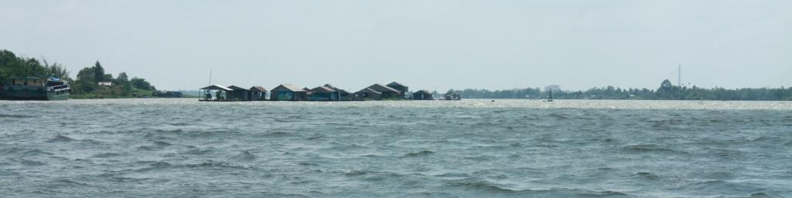
Deltas Youth Alliance group in Can Tho City would like to organize this trip for students and some experiences persons who are working on those issues in Mekong Region and Mekong Delta in order to share and learn each other. There are many issues in the Mekong Delta which related this island to development issues including dyke system; erosion; water governance; livelihood; land title; Tra fish farm; and so on.
Time, location and participants
- Time/date: In the morning 17 March 2013 (Sunday)
- Location: Son Island
- Participants: 20 people and we are priority Deltas Youth Alliance members

Eligible to apply
- Members of Deltas Youth Alliance, Gender, Ethnicity, fields background are balance
- To care and concern development issues
- Willing to travel to rural area;
- Contribute fee during traveling to island;
- Common English because some participants are from America and Thailand;
Benefits
- Learning from professors and experts on development issues;
- Travel to island by boat; tea break and lunch will cover by Deltas Youth Alliance; travel outside of Can Tho City and accommodation during staying in Can Tho City will be covered by participants;
Contact and register
Please contact us by email at deltasyouth@gmail.com, or reach us at +84 986 240 562 Mr. Nguyen Thong Tha) for more information and to submit your application, the application form may follow:
Your information (name/ age/ gender; ethnicity; phone number; where are you coming from?)
What are you doing or studying now? Where is there? Tell more about your work or your studying?
Why are you interested this trip?
Please submitting your application before March 13rd 2013, we will notice after a day while your application is successfully chosen.
Trip schedule to Son Island – 17 March 2013
Time | Description
8:00 am | 20 participants are leaving from Guesthouse Number 2 by motorbikes, each students take care each participant from America and Thailand
8:30 am | Arriving the ferry station, taking the boats from the ferry to island  Present from Deltas Youth Alliance group
8:45 am | Arriving island, preparing to walk around island on dyke system  Present from Deltas Youth Alliance group
 | 1,5 hours to 2 hours by walking, six kilometers of long dyke
10: 00 am | Arriving rest stop house, one of families in the island to take rest, drink water, tea break and take fruit
10: 45 am | Leaving the family to walk continuously to ferry station in the island  Playing games from Mekong School alumni and Deltas Youth Alliance group
11:15 am | Taking boat and ferry station in the inland
11:30 am | Leaving the ferry to ride motorbikes to Khuong Island for lunch
12:00 am | Arriving Khuong Island restaurant
13:30 pm | Leaving Khuong Island to go back Guest House number 2

