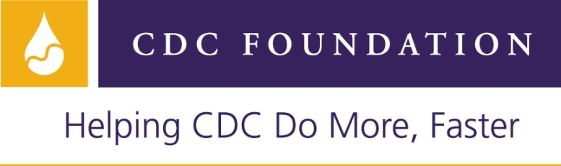

Position Announcement: August 10, 2011
Position Title: Logistical Coordinator
Temporary Hourly Position, September 19, 2011 –December 23, 2011
Compensation: FSN-8 step 1 basic salary level of US $5.00 per hour

Established by Congress as an independent, nonprofit organization, the CDC Foundation connects the Centers for Disease Control and Prevention (CDC) with private-sector organizations and individuals to build public health programs that make our world healthier and safer. Since 1995, the CDC Foundation has provided $300 million to support CDC's work, launched more than 500 programs around the world and built a network of individuals and organizations committed to supporting CDC and public health.

We are seeking a temporary Logistical Coordinator who will be responsible for assisting with planning and implementation of the 2011 Management for Improved Public Health (MIPH) Course in Hanoi Vietnam from November 28, 2011 – December 13, 2011. The MIPH Course is an interactive training program for public health managers designed to improve their management and leadership skills. Participants will travel from around the globe, including Asia, Africa and the Americas to attend the Hanoi course. The course organizers and faculty reside in the United States and will be planning for the course remotely, but will be in Hanoi throughout course implementation.

This position will be paid on a contractual basis. We anticipate approximately 20 hours of work per week in September, October and November, and 40 hours per week during the course, with occasional work on nights and weekends.

DUTIES:
- Act as point person in Hanoi for communication and coordination with CDC Atlanta, CDC Vietnam, and Hanoi hotel.
- Work with CDC foundation to arrange local transportation for participants and faculty to and from airport, social events, site visits, and other venues as needed. This will involve researching transportation companies, negotiating terms and conditions, and submitting contract to CDC Foundation.
- Follow up with all participants to ensure they have arranged accommodation.
- Assist with visa/passport/travel needs of participants and event staff. Determine visa needs, and work with CDC Vietnam to send letter of invitation, VAIN applications and VAIN numbers as needed.
- Work with CDC staff and Hanoi hotel to plan for opening/closing receptions, social events, and local site visit.
- Track and confirm receipt of materials shipped from CDC Atlanta to hotel.
- Assemble welcome packets.
- Research translation services as needed.
- Prepare laptop, LCD and printer prior to event.
- Prepare name tags for participants and name tents for faculty.
- Acquire and prepare office supplies as needed.
- Create CDs that contain all course materials, photos and other useful information for participants on the last day of the course.
- Register and greet participants as they arrive.
- Be available throughout entirety of course to deal with logistical issues as they arise: transportation, printing, visa/passport, technical issues, other faculty requests.
- Assist with other duties as needed.

QUALIFICATIONS:
- Fluency in English is required. Applicants must have excellent writing, reading, and oral English skills.
- Fluency in Vietnamese is desired.
- Bachelor’s degree required.
- At least two years experience in planning and implementation of events in Vietnam.
- Ability to work with diverse groups of people from across the globe.
- Excellent ability to solve problems and use of creative approaches to completing tasks and solving problems.
- Excellent written and verbal communication skills.
- Experience with computers including word processing, spreadsheet, and database management skills.
- Excellent interpersonal and organizational skills.
- Access to office supplies, including laptop/printer/copy machine, that will facilitate completion of work in a timely manner.
- Ability to handle confidential information in a discreet and professional manner.

Qualified candidates should submit cover letter, resume, and two references to Bernice Tannor at BTannor@cdcfoundation.org. Information must be received by Wednesday, August 24, 2011.

In-person meetings with qualified candidates will take place in Hanoi the week of September 5th, 2011.

The CDC Foundation is an equal opportunity employer.

